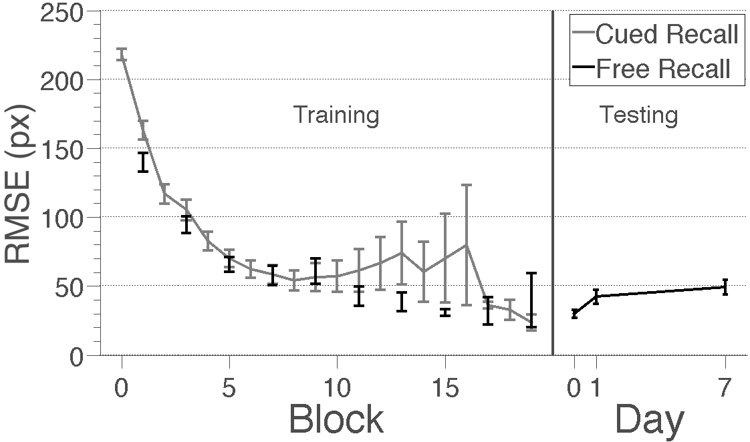
Figure 7. Learning and forgetting in Experiment 3 measured in root mean square error (RMSE) for the cued recall task during training and the free recall task during training and testing. The grey line indicates cued recall performance and the black points and line indicate free recall performance. Training results reflect all 74 subjects that finished session 1 and testing results reflect the 25 subjects that finished all three sessions. Cued and free recall performance during training were very similar. Error bars indicate ±1 SEM across subjects.

